1.Create a simple cloud-based application for managing Patient–Doctor details and provide it as a service using any Cloud Service Provider to demonstrate the concept of Software as a Service (SaaS).

**Aim**

To design and deploy a simple cloud-based application for managing Patient and Doctor details using a Cloud Service Provider and demonstrate the concept of Software as a Service (SaaS).

**Procedure**

1. **Requirement Analysis**
   * Identify modules: Patient management, Doctor management, and Appointment scheduling.
2. **Application Development**
   * Frontend: Create forms for entering and viewing Patient/Doctor details.
   * Backend: Use Flask (Python) or Node.js to handle requests and Database: Configure cloud database (e.g., Firebase Firestore / AWS RDS / SQLite for demo).
3. **Cloud Deployment**
   * Choose a cloud provider: Firebase, AWS, Azure, or Zoho Creator.
   * Deploy the backend API and frontend on the chosen platform.
   * Ensure application is accessible via a browser (SaaS model).
4. **Testing**
   * Add new patients and doctors.
   * View details and check appointment assignment.
   * Verify multi-user access from different devices.

Output:

Patient details:

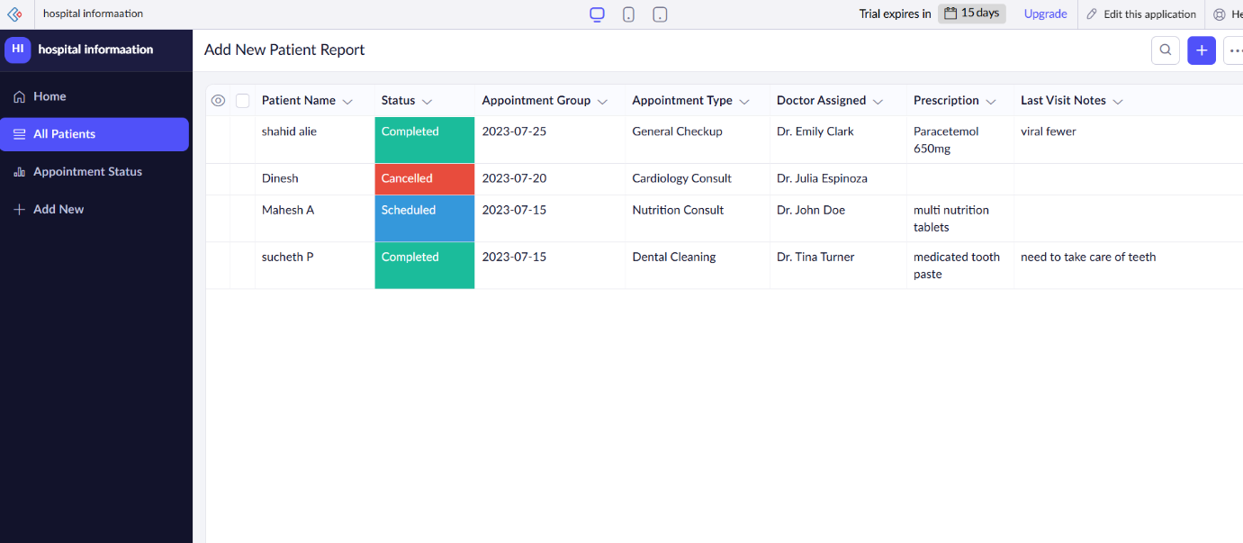

Doctor details:

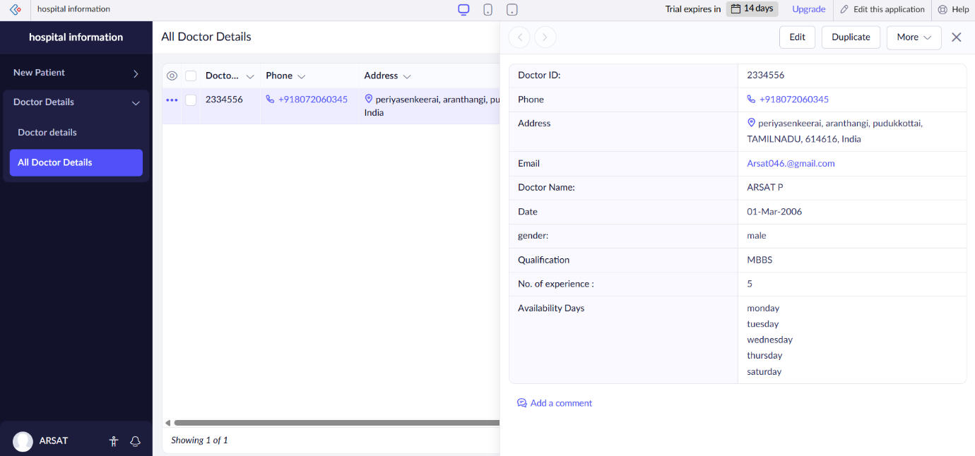

**Result**

A cloud-hosted Patient–Doctor Management Application was successfully developed and deployed as a SaaS solution.